Session 11
1.
Create a SQL query using a subquery in the WHERE clause to find all restaurants from a 'Restaurants' table whose average rating is higher than the average rating of all restaurants in the city.
Ans :
SELECT
r.restaurant_name,
AVG(rv.rating) AS Average_Rating
FROM Restaurants r
JOIN Reviews rv
ON r.id = rv.restaurant_id
GROUP BY r.id, r.restaurant_name
HAVING AVG(rv.rating) >
(
SELECT AVG(rating)
FROM Reviews
);
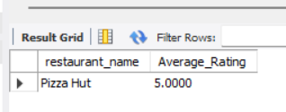

2.
Write a SQL query that uses a subquery in the SELECT statement to display each user's name from a 'Users' table along with the total number of orders they have placed from an 'Orders' table, like a summary you might see in a Zomato user profile.
Ans :

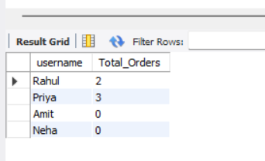

SELECT u.username,
( SELECT COUNT(*)
FROM Orders o
WHERE o.user_id = u.id
) AS Total_Orders
FROM Users u;
3.
Given a 'Movies' table and a 'Reviews' table, write a SQL query using IN with a subquery to list all movies that have at least one review with a rating of 5 stars, as seen in BookMyShow's top-rated section.
Ans :
SELECT
movie_name
FROM Movies
WHERE id IN
(
SELECT movie_id
FROM Reviews
WHERE rating = 5
);

4.
Write a nested SQL query to find the names of all sellers from a 'Sellers' table on a Flipkart-style platform who have sold products in every category listed in a 'Categories' table.<br><br><em><strong>Hint:</strong> Use nested subqueries to compare seller's categories with the complete list of categories.</em>
Ans : CREATE TABLE Sellers (
seller_id INT PRIMARY KEY,
seller_name VARCHAR(100)
);

CREATE TABLE Categories (
category_id INT PRIMARY KEY,
category_name VARCHAR(100)
);

CREATE TABLE Products (
product_id INT PRIMARY KEY,
seller_id INT,
category_id INT
);

INSERT INTO Sellers VALUES
(1,'ABC Store'),
(2,'XYZ Shop'),
(3,'Best Mart');

INSERT INTO Categories VALUES
(101,'Electronics'),
(102,'Fashion'),
(103,'Grocery');

INSERT INTO Products VALUES
(1,1,101),
(2,1,102),
(3,1,103),
(4,2,101),
(5,2,102),
(6,3,103);

SELECT
seller_name
FROM Sellers s
WHERE
(
SELECT COUNT(DISTINCT category_id)
FROM Products p
WHERE p.seller_id = s.seller_id
)
=
(
SELECT COUNT(*)
FROM Categories
);

